**Kingston SQL Test**

--1.Write a well-structured tSQL query to calculate the Total profits per order, for orders of type = A ordered in the year 2021.

SELECT

OL.Order_ID,

SUM(OL.Order_Qty*(OL.Unit_Price-OL.Unit_Cost)) AS Total_Profits

FROM OrderLines OL

INNER JOIN OrderHeader OH

ON OL.Order_ID = OH.Order_ID

WHERE OH.Order_Type = 'A'

AND OH.Order_Date LIKE '%2021%'

GROUP BY OL.Order_ID

Order By OL.Order_ID

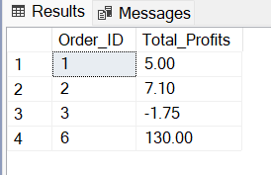

--2.Write a well-structured tSQL query to insert a new product called TWY-1 of group type X in the products table

INSERT INTO Product

VALUES ('TWY-1', 'X')

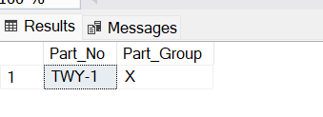

--3.Write a well-structured tSQL query to calculate the Total profits and Total Qty by Part Group for orders in February 2021.

SELECT

P.Part_Group,

SUM(OL.Order_Qty) AS Total_Qty,

SUM(OL.Order_Qty*(OL.Unit_Price-OL.Unit_Cost)) AS Total_Profits

FROM OrderLines OL

INNER JOIN OrderHeader OH

ON OL.Order_ID = OH.Order_ID

INNER JOIN Product P

ON P.Part_No = OL.Part_No

WHERE OH.Order_Date LIKE '%/02/2021%'

GROUP BY P.Part_Group

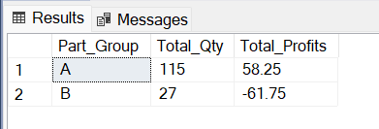

--4.Write a well-structured tSQL query to Update the order line status to 999 for the orders 100000 and 100001 and order type B.

update OrderLines set Status = 999

where Order_ID IN

(SELECT Order_ID

FROM OrderHeader

WHERE Order_Type ='B' AND Order_No between 100000 AND 100001 )

